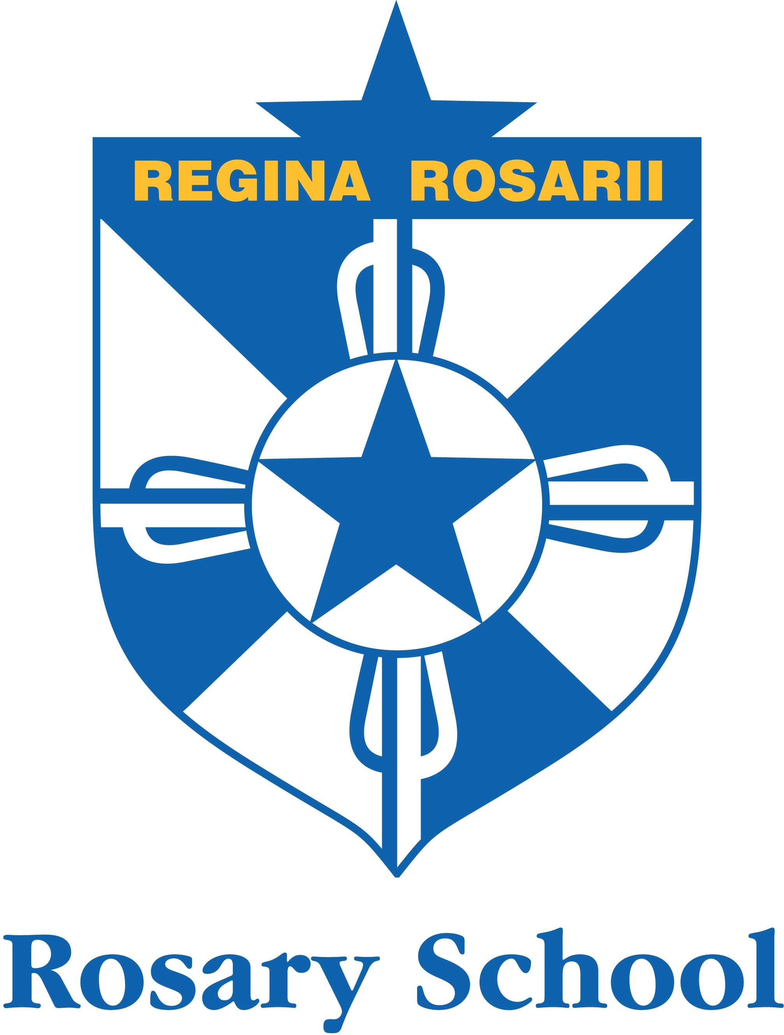 | 15 Gladstone Road  Prospect 5082 | t (08) 8343 5700  f (08) 8343 5764  e rosary.school@rosary.catholic.edu.au  www.rosary.catholic.edu.au

Friday 20th November, 2020

Dear Parents/Caregivers,

I hope you continue to be well and have heard the great news from the Premier that schools will re-open from Monday 23 November.

This means the resumption of normal classes for all of our students.

Here are some specifics for our site: Parents will be asked to stay off site until further notice.
Drop off arrangements:
We will revert back to our Term 2 restrictions – dropping your child off at the gate. The gates open at 8:20am.

Pick Up arrangements:
Kiss and drop should be used where possible to avoid parents gathering. Please stay in your car and the children will walk to you under supervision.
Other Parents will need to wait at the gates for dismissal.
Reception classes will make their way to the gym/jubilee area with their teacher, ready to be picked up at 2:50pm.
Other children will make their way to the gates at 3pm. Please tell your child which gate you will be collecting them from.

Please note that we are seeking clarification on some aspects of the operation of other school activities, but for the time being the school will be open as it was last Monday (including changes to events)

Students should return to school with all the materials and equipment they took home last week including their device and charger.

You may have heard reports about masks and our understanding right now is that masks are not compulsory. Some people may choose to wear masks, especially when travelling, but there is no expectation that your child needs to wear a mask whilst at school.

I will keep you informed if there is a change.

If you have any questions or concerns, please contact the school on Monday.
Please keep safe and well in this time and I look forward to seeing you soon.
Regards
Trish O’Toole

